**Horizon Europe Programme**

Research and Innovation Action

This project has received funding from European Union Horizon Europe programme, under Grant Agreement N°101080923

**Start date of project: 1st May 2023**

**Duration: 42 months**

**Public Report – OLLD 2024 Results**

**Game On: Co-Creating Future-Ready Mental Health Solutions with Young Minds**

***Engaging Stakeholders Through SMILE's Innovative Approach: The 'Game On' Workshop Experience***

**Event Overview**

From September 25th to 27th, 2024, members of the SMILE consortium – [INTRAS](https://www.horizonsmile.eu/partners/#intras)**,** [UoM](https://www.horizonsmile.eu/partners/#unimaribor)**, and** [IRCCS-AouBO](https://www.horizonsmile.eu/partners/#azienda) – attended the Open Living Labs Days (OLLD) in Timișoara, hosted by the European Network of Living Labs (ENOLL). During this event, the SMILE team delivered a workshop focused on user experience and pilot implementation strategies for AI-based mental health tools. The session, held on September 25th, brought together 20 researchers, health professionals, and other key stakeholders to address one of today's biggest challenges: mental health among young people.

The workshop provided a platform for participants to engage with SMILE's digital tools, particularly the Companion App developed by [RDIUP](https://www.horizonsmile.eu/partners/#rdiup), as well as AI-based mental health games. Participants collaborated to test, refine, and improve the prototype, ensuring it is tailored to the needs of the target audience. During the session, they also contributed to the co-creation of impactful solutions by helping map out the best ways to implement this innovative tool, aiming to reach and engage over 2,000 young users effectively.

The experiential and interactive methodologies used at OLLD highlighted the project's focus on combining innovative technologies with real-world applications, laying the groundwork for SMILE’s future implementation strategies.

### Workshop Exercises and Key Insights

### Results Description

**First Part: "In Their Shoes"**

Participants adopted the viewpoints of key user personas to hypothesise their thoughts, emotions, and actions when engaging with the SMILE Companion App. Participants documented these reflections and identified potential opportunities, needs, obstacles, and limitations each persona might encounter following the template below:

This exercise highlighted important perspectives and areas for improvement across several user groups:

#### **Persona Profiles and Findings**

1. **Frank, the Teacher**
   * **Says**: "How does this align with the curriculum?" Frank is interested in giving feedback but avoids direct calls to action.
   * **Thinks**: Considers the app's relevance to quality time, potential use with psychological tools, but feels it doesn’t fully meet her needs.
   * **Does**: Adopts a passive role in the app’s use.
   * **Feels**: Worried about screen time for students.

**Opportunities / Needs**

* + Training for teachers/educators
  + Identifying classroom topics through survey results

**Limitations / Obstacles**

* + Unsure how it fits as a teaching resource
  + Concerned about age appropriateness and survey data usability.

1. **Sara, the Healthcare Professional**
   * **Says**: Notes the variation among personas and potential for tracking progress through the app.
   * **Thinks**: Time constraints, data sensitivity, and varying needs of each persona.
   * **Does**: Discusses app features with colleagues, encountering differing views.
   * **Feels**: Skeptical and nervous about acceptance among patients and colleagues.

**Opportunities / Needs**

* + Regular reporting, such as weekly summaries
  + Trust-building elements to encourage acceptance

**Limitations / Obstacles**

* + Lack of time
  + Concerns about data privacy and security.

1. **John, a 16-Year-Old User**
   * **Thinks**: Seeks clear context, confidentiality, and a safe space for engagement.
   * **Does**: Engages with the app but feels pressured to respond quickly.
   * **Feels**: Experiences anxiety, negative thoughts, curiosity, and relief.

**Opportunities / Needs**

* + Accessibility and ease of use
  + Engagement elements, such as meditation and guided practices

**Limitations / Obstacles**

* + Concerns about confidentiality and comfort
  + Initial hesitation or confusion about purpose.

1. **Alicia, a 20-Year-Old User**
   * **Thinks**: Resists overuse of her phone and lacks the energy to stay engaged.
   * **Does**: Checks her phone for updates and shares information about the app with others.
   * **Feels**: Experiences reduced stigma and a sense of belonging, sharing openly without fear of judgment.

**Opportunities / Needs**

* + Encourages a sense of community
  + Provides a cost-effective alternative for those without access to professional support

**Limitations / Obstacles**

* + Privacy concerns
  + Uncertainty about continuous use and potential lack of energy.

1. **Parent**
   * **Says**: "Encourage my children to try new tools."
   * **Thinks**: Worries about screen time, preferring outdoor activities for mental wellness.
   * **Does**: Reflects on children’s emotional states and tracks their progress.
   * **Feels**: Hopeful initially but cautious about potential negative effects from continuous questioning.

**Opportunities / Needs**

* + Joint app use for parents and children
  + Parental guidance resources and motivational tools

**Limitations / Obstacles**

* + Maintaining children’s engagement over time
  + Concerns about honesty from children due to monitoring and lack of engagement

### Second Part: ****In Their Shoes – Results****

In the second part of the SMILE project workshop at OLLD, participants engaged in the key exercise **"In Their Shoes: Results."** These sessions further analysed the SMILE app's implementation process and provided structured feedback based on each persona's perspective following the template below:

This exercise synthesised each persona's final thoughts, including positive impressions, unclear elements, and missing features, offering a clear framework of gathered insights.

#### **Persona Insights and Feedback**

1. **Frank (Teacher)**
   * **Unclear Aspects**:
     + Effectiveness in teaching students to articulate distress and practice communication skills.
     + Practicality of integrating the app into quality time and education routines.
   * **Missing Aspects**:
     + Clear mechanisms for promoting well-being and teaching students when and how to seek help.
     + Destigmatising help-seeking behaviours, especially considering potential digital divides.
2. **Sara (Healthcare Professional)**
   * **Positive Aspects**:
     + Early detection of youth mental health issues, self-assessment tools, and cognitive-behavioural therapy (CBT) elements.
   * **Unclear Aspects**:
     + How the app will promote coping strategies beyond escapism and apply these skills outside the game.
     + Reliable, evidence-based resources and content that improve young people’s social competencies.
   * **Missing Aspects**:
     + Preventative measures to reduce serious risks, virtual rewards (e.g., "communication skills" or "life satisfaction" points), and collaborative features that encourage friend networks.
3. **John (16-Year-Old User)**
   * **Unclear Aspects**:
     + Personalisation options for avatars, a compelling narrative, and high-quality graphics for relaxation.
   * **Missing Aspects**:
     + A clear protagonist role for users, enhancing their engagement with a personal storyline.
   * **Additional Notes**:
     + Importance of user identification with the app, suggestions like guided meditation, and the use of relatable language.
4. **Alicia (20-Year-Old User)**
   * **Unclear Aspects**:
     + Potential for free access or device compatibility to improve usage feasibility.
   * **Missing Aspects**:
     + Anonymous discussion options on various topics, features for learning new skills, and a non-judgmental environment for seeking advice.
5. **Parent**
   * **Unclear Aspects**:
     + Encouraging problem-solving and decision-making skills within the app and progression through different levels.
   * **Missing Aspects**:
     + Child-oriented coping strategies, rules protecting youth anonymity, data storage transparency, and guidance on addressing specific mental health needs.

### Third Part: ****Real World Testing Journey****

In the third part of the SMILE project workshop at OLLD, participants engaged in the **"Real World Testing Journey"** key exercise. This session further analysed the SMILE app's implementation process and provided structured feedback based on each persona's perspective.

Participants explored the phases of SMILE’s game and app implementation, focusing on each stakeholder group's role and the specific actions needed at each stage:

* **A**: Recruitment Strategy.
* **B**: Recruitment.
* **C:** After Recruitment: Explanation and Installation.
* **D:** Intervention Period.
* **E**: Qualitative Evaluation.
* **F:** Results review on UX (user’s experience).
* **G:** Incremental Development.

This analysis highlighted the real-world dynamics involved in launching the SMILE tools, helping partners identify practical steps to engage and address each stakeholder's needs through the project lifecycle. Examples of considerations in this exercise included:

* Initial engagement strategies for younger users and parents.
* Communication channels and feedback loops for healthcare professionals.
* Educational aspects and curriculum alignment for teachers.

This process ensured a well-rounded approach to addressing the unique requirements of different users in real-world settings following the template below:

In the following tables are the “real voices” of each assigned group:

**Table 1 (Group 1):**

|  |  |  |
| --- | --- | --- |
| **Phases** | **A. Recruitement Strategy** | **B. Recruitement** |
| **Actions** | -Direct contact with different experts  -Ask different experts «how would you suggest recruitment» | -Incentive  -Put in place the co-designed strategy  -Children science museum |
| **Interactions** | -Ask for help to developing the tool and for feedback  -Youth workers  -Go to youth work setting and ask through workshop  -Healthcare professionals and needs some incentives as an expert  -Gets parents and children supporting the strategy (they have the experience) |  |

**Table 2- Group 2**

|  |  |  |  |  |  |  |
| --- | --- | --- | --- | --- | --- | --- |
| **Phases** | **A. Recruitement Strategy** | **B. Recruitement** | **C. After Recruitment** | **D. Intervention period** | **E. Qualitative evaluation** | **F. UX analysis** |
| **Actions** | -School newsletters  -Sport clubs  -Include school psychologists | -Parents  -Child 10-14 years  -Child 15-19 years  -Young people 20-24 years  -Healthcare professionals | Collective Session: Testing + Explanation (in person + online) | Parents involvement | -Focus groups with parents  -Individual Interviews  -Drawings | UX data analysis platform |
| **Interactions** | Ask kids | Classrooms/ schools | Classrooms/ schools | House;  Healthcare Professionals |  |  |

**Table 3-Group 3**

|  |  |  |  |  |  |
| --- | --- | --- | --- | --- | --- |
| **Phases** | **A. Recruitement Strategy** | **B. Recruitement** | **C. After Recruitment** | **D. Intervention period** | **E. Qualitative evaluation** |
| Actions | -Online advertisement  -QR code with a trailer and a subscription link  -Through teachers, mentors but only when discussing the topic and painting out the link  -Posters  -Collaborate with a mental healthcare campaign of the city  -Online and offline influencers telling how it works for them | Screening the target group | -Pre-recorded video  -Onboarding / training by professionals / peers  -Consent | -At least 6 months / a year  -They decide themselves how often they fill out the questionnaire | -Feedback session (voluntary) |
| Interactions | -Teachers  -Playground schools  -Parents |  |  |  |  |

**Table 4-Group 4**

|  |  |  |  |  |  |  |  |
| --- | --- | --- | --- | --- | --- | --- | --- |
| **Phases** | **A. Recruitement Strategy** | **B. Recruitement** | **C. After Recruitment** | **D. Intervention period** | **E. Qualitative evaluation** | **F. UX analysis** | **G. Incremental development** |
| Actions | Stakeholders mapping  -Invite local communities  -Co-creative recruitment strategy | Collaborate with healthcare professionals and schools | Engaging activities  -Q&A sessions | -User support  -Inform about updates | Experts’ advice  -Results graphics |  |  |
| Interactions | -Teachers  -Playground schools  -  Classroom schools | -Teachers  -Playground schools  -Classroom schools  -House | -Classroom schools  -House | -Parents  -Child 10-14 years  -Child 15-19 years  -Young people 20-24 years  -Healthcare professionals | -Child 15-19 years  -Young people 20-24 years  -Healthcare professionals  -Researchers  -House | -Healthcare professionals  -Researchers | -Healthcare professionals  -Researchers |

**Table 5-Group 5**

|  |  |  |  |  |  |  |  |
| --- | --- | --- | --- | --- | --- | --- | --- |
| **Phases** | **A. Recruitement Strategy** | **B. Recruitement** | **C. After Recruitment** | **D. Intervention period** | **E. Qualitative evaluation** | **F. UX analysis** | **G. Incremental development** |
| Actions | Social Media  Events on how to use it  School visits  Recommendations | Events  -Game activities | Using the app | Collecting data- feedback | Statistics | Survey | Suggestions to extend the target group of the users |
| Interactions |  |  |  |  |  |  |  |

### Summary and Next Steps

The OLLD event offered SMILE’s partners a practical introduction to **interactive stakeholder engagement and user-centric design**, key approaches they can apply to the project. The insights gained will be instrumental in refining SMILE’s tools to meet the diverse needs of target user groups and ensure that the app effectively addresses stakeholder concerns while promoting mental health. By focusing on both opportunities and limitations, the SMILE team is well-equipped to create inclusive, engaging, and impactful digital mental health solutions.

From the "Real World Testing Journey" and the two "In Their Shoes" exercises enriched SMILE partners with actionable feedback to fine-tune the app's features and implementation approach. The feedback emphasizes the need for:

* **Personalisation** and **engagement** features tailored to younger users.
* **Evidence-based resources** and tools that align with professional standards in mental health.
* **User support mechanisms** to maintain user privacy, encourage active participation, and offer meaningful guidance for parents and teachers.

These detailed perspectives form a robust foundation for refining the SMILE project’s tools and ensuring they effectively meet the needs and expectations of diverse user groups.

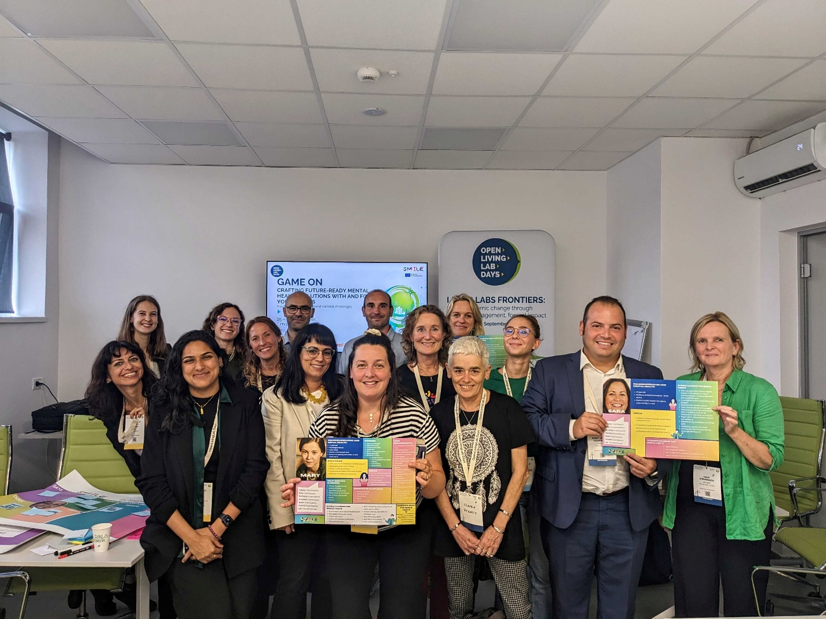

Disclaimer: SMILE is a project co-funded by the European Commission under the Horizon Europe Programme - Call: HORIZON-HLTH-2022-STAYHLTH-01-two-stage under Grant Agreement No. 101080923.

Legal notice: The information and views set out in this publication are those of the author(s) and do not necessarily reflect the official opinion of the European Communities. Neither the European Union institutions and bodies nor any person acting on their behalf may be held responsible for the use, which may be made, of the information contained therein.

© Copyright in this document remains vested with the SMILE Partners

**Contact**

Project Coordinator: Dr. Dominic Heutelbeck

FTK e.V. - Forschungsinstitut für Telekommunikation und Kooperation

Wandweg 3, 44149 Dortmund, 0231 - 975056-0

|  |  |
| --- | --- |
|  |  |
| @HorizonSmile |
| www.linkedin.com/company/HorizonSmile/ |
| @HESmile_project |

|  |  |
| --- | --- |
|  | Funded by the European Union under Grant Agreement No°101080923. Views and opinions expressed are however those of the author(s) only and do not necessarily reflect those of the European Union. Neither the European Union nor the granting authority can be held responsible for them**.** |